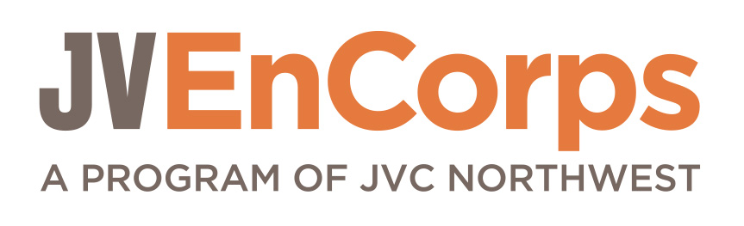

Dear Applicant:

Thank you for your interest in being part of the JV EnCorps program this year. Please read the overview of the program’s transformative opportunities for service and spiritual formation . We hope you will be inspired! Please retain this cover letter for your reference.

jv encorps program overview
JV EnCorps, a program of Jesuit Volunteer Corps (JVC) Northwest, engages women and men ages 50 and older in a transformative experience of volunteer service and spiritual growth. Participants (JVEs) commit to 10 months (September – June) of service in their local communities and to the exploration of JVC Northwest’s core values: community, simple living, spirituality, and social & environmental justice.

The JV EnCorps experience includes:
- Volunteer service for 10 months in one community agency or institution for 5 – 10 hours weekly
- Monthly JVE community meetings plus three all-day retreats for learning, reflection and spiritual growth
- Commitment to building a JVE community of like values and serving others
- Sustaining an individual practice of prayer, meditation and/or reflection
JVEs may be placed in a community agency by JVC Northwest or a JVE may already have an established volunteer placement that fits the mission of JVC Northwest.
agency criteria for jv encorps service placements

- Agencies directly serving people who are economically poor or working to address the issues and structures impacting marginalized populations.
- Agencies able to provide minimum service requirements to meet the JVE time commitment of five or more hours a week, September - June.
- Agencies able to offer volunteers (50 years and older) meaningful service opportunities and enrichment.

Mail your completed application by June 30th to:

Jesuit Volunteer EnCorps
P.O. Box 3928
Portland, OR 97208
jvencorps@jvcnorthwest.org

what happens next
Interview: When we receive your completed application, we will contact you to schedule an interview. This will be an opportunity to review program specifics, for us to get acquainted and to explore the fit. The interview will last about one hour. Following the interview, JV EnCorps will notify you whether you’ve been accepted into the program.

Site Placement Process: After you are accepted into the program, JV EnCorps staff will work with you to confirm or identify a site placement that best fits your interests, local non-profit agencies’ needs, and the mission of JVC Northwest. This could include a site where you already volunteer. Some agencies may also require their own interview. You may be asked to provide additional information, e.g., driver’s license and insurance information, or to complete additional paperwork such as permission to conduct a criminal background check, etc. These requirements may vary based on the site placement.

Key Dates:
Application Deadline: June 30th
Orientation Retreat: TBD (late August)

community * simple living * social & ecological justice * spirituality

Jesuit Volunteer EnCorps: 2014 – 2015 Application

Mail completed application to:

JV EnCorps or deliver to:
P.O. Box 3928 3928 North Williams
Portland, OR 97208 Portland, OR 97227

Call 503-335-8202 or email jvencorps@jvcnorthwest.org if you have any questions.

CONTACT INFORMATION

FIRST NAME MIDDLE NAME LAST NAME

ADDRESS

CITY, STATE, ZIP

E-MAIL PRIMARY PHONE OTHER PHONE(S)
PREFERRED WAY TO REACH YOU (PLEASE CHECK ONE): PHONE EMAIL

DATE OF BIRTH (Month/Day/Year): / /

Application Form Page 1 of 5

Personal Information - Please

CURRENT WORK STATUS

Retired/not working Working part-time/semi-retired Working full-time

PROFESSIONAL CERTIFICATES OR LICENSES (if applicable)
 Education  Medicine  Nursing  Law  Social Work  Other___________________n

SPIRITUAL AFFILIATION and/or PARISH/CONGREGATION (if applicable)
____________________________________________________________________________________________________________________________________________________________________________________

HOW DID YOU HEAR ABOUT JV ENCORPS?

__________________________________________________________________________________________
work and service experience
Please list work positions (paid and volunteer) and fulfilling hobbies/adventures you’ve had:

I commit to 5-6 volunteer hours a week I commit to 8-10 volunteer hours a week

site placement preferences

If you have already identified a specific volunteer position or non-profit organization you would like to use as your JVE placement, please indicate it here:

ORGANIZATION/AGENCY

SUPERVISOR PHONE NUMBER

E-MAIL

VOLUNTEER ROLE & DUTIES

__________________________________________________________________________________________________________

personal statement

In no more than 2 pages, please share your expectations of the JV EnCorps experience, using the following questions and program components as a guide.

- How is this JV EnCorps experience a good fit for your life at this time?
- What personal intentions do you have for this year in JV EnCorps?
- Which JV EnCorps program components and core values do you find challenging?
- Which program components highlight your talents and expertise? Why?
- Include any other reflections and expectations you wish to share.

Program Components:
- Serving and/or working alongside people who are materially poor or marginalized
- Reflection, advocacy, and action against oppression and social/ecological injustice
- Ignatian spirituality and practices (i.e., spiritual exercises, examen, etc.) *
- JVE community meetings and retreats for mutual support and shared reflection
- Personal commitment to daily spiritual practice
- Simple living

*Though grounded in the Catholic Ignatian tradition, JV EnCorps welcomes people from all spiritual traditions and encourages openness to the spiritual paths of others.

financial contribution

Recognizing there are expenses involved in creating and sustaining the valuable community aspects of the JV EnCorps program, we ask that JV EnCorps participants make a program contribution according to their ability and financial situation. If unable to commit to the recommended contribution of $200 ($20 a month) over the ten months of the program, we ask for an amount that is financially affordable. This $200 represents only a portion of the costs of administering the JV EnCorps program.

about jvc northwest

Jesuit Volunteer Corps Northwest engages women and men of all ages in a transforming experience of volunteer service. Jesuit Volunteers serve in solidarity with persons living on the margins of society and with vulnerable places throughout the Pacific Northwest.
Rooted for over fifty years in the Jesuit Catholic tradition emphasizing spiritual openness and depth, Jesuit Volunteers in the Northwest examine and act on the causes of social and environmental injustice to promote peace and structural change.
JV EnCorps was created in 2011 to meet the needs of the growing number of retired people or those moving into retirement who seek: to remain vital and active; meaningful work benefiting society; a supportive spiritual community; and, personal meaning and fulfillment.

I certify that the statements made in this volunteer application and accompanying documents are true and correct, and have been given voluntarily. I understand that volunteers are not employees of JVC Northwest and that if accepted as a volunteer, I do not expect and will not be paid or receive any remuneration for my services as a volunteer. I understand that all materials become property of JVC Northwest and that none of the materials will be returned to me. I also understand that some or all of the application materials may be reviewed by placement sites for which I am considered.

Signature Date

Place Stamp Here

P.O. Box 3928
Portland, OR 97208-3928

