Employers for National Service Opportunity
“If you’re an employer who wants to hire talented, dedicated, patriotic, skilled, tireless, energetic workers, look to AmeriCorps, look to the Peace Corps… Citizens who perform national service are special. You want them on your team.”
– President Obama
As part of the 20th anniversary of AmeriCorps commemoration at the White House, President Obama announced Employers of National Service, a new cross-sector partnership that encourages employers to create recruitment, hiring, and advancement opportunities for alumni of AmeriCorps and Peace Corps.

How can you become an Employer for National Service?
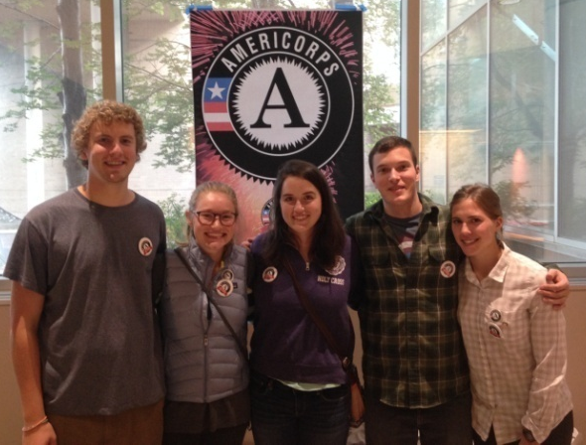
Join nonprofits, corporations, local government entities and federal government agencies across the nation who are indicating interest in hiring national service alumni in relevant job postings and placing a checkbox on job applications that asks about past national service experience.
Any employer that signs up to participate by December 31, 2014 will be considered a charter Employer of National Service. Email employers@cns.gov.

Links:
CNCS Website: http://www.nationalservice.gov/special-initiatives/employers-national-service
Fact Sheet: http://www.nationalservice.gov/documents/fact-sheets/2014/employers-national-service-fact-sheet
President Obama's Speech: http://blog.americorpsalums.org/2014/09/12/president-announces-new-initiative-employers-of-service/
Top 5 Skills AmeriCorps Members Bring: http://c.ymcdn.com/sites/www.americorpsalums.org/resource/resmgr/Employers_of_National_Service/Top.5.Skills.pdf

