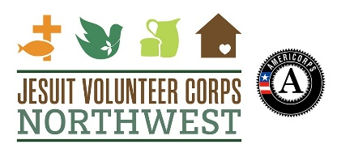
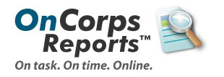
2016-2017

Greetings JV AmeriCorps members! Please review the instructions below and let us know if you have any questions. Accurate and regular timekeeping and reporting are essential for us to keep our program going and make sure everything stays on track for a successful program year!

Great Stories
At some point throughout the year, we ask that you submit at least one “Great Story.” This is a story of impact. It is an opportunity to share some of the amazing things that happen throughout the year in an anecdotal way.

It can be simple! Stories of transformation are great, but stories of one little thing that happened are just as good. One JV last year simply typed up the contents of a two-sentence letter written to her by one of her clients that thanked her for her presence.

IDEAS FOR GREAT STORIES
Impact Snapshots: Tell a quick story describing where you serve, a concrete issue encountered, what you/and others did to address it, and how things improved for your organization/beneficiaries.
- At [Program Name] in [Locale], I became aware that [issue]. Along with [Other Folks Involved], I [Action Step/Service Activity]. As a result [Impact]. Feel free to be creative with form.
Story Topic Ideas: Health and wellness, environmental stewardship, engaging community volunteers, how has service affected your next life steps, how did different groups come together to address a community issue, how does your site fill a particular need, describe a memorable day in service….
Helpful hints: In addition to speaking from the heart…
- Keep things brief. Try to stay within 300 words if possible. Shorter allows us to share your voice.
- When possible, quantify things. How many people were involved? How much did things change?

To Submit:
- Log in.
- Along the top, you’ll find “Reporting.” Hover over it, then hover over “Submit Reports” and select “Great Stories.”

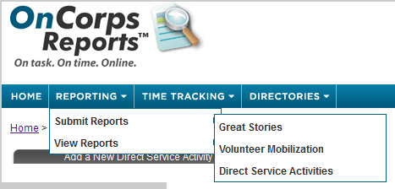

- Title what you want and enter the date—the reporting period doesn’t matter—you can choose Q1, and share that great story!!

