2016-2017

Greetings JV AmeriCorps members! Please review the instructions below and let us know if you have any questions. Accurate and regular timekeeping and reporting are essential for us to keep our program going and make sure everything stays on track for a successful program year!

Volunteer Mobilization
Along with timesheets and direct service activity reports, EVERY MONTH, at the end of the month, you must also submit a Volunteer Mobilization report, whether or not you have recruited or managed any volunteers!

Mobilizing (recruiting and managing community volunteers) is a top priority for the Corporation for National and Community Service. Please help us share the impact you have in this area!

Here's how you do it:

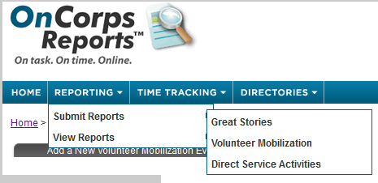

- In OnCorps, follow Reporting>Submit Reports>Volunteer Mobilization.
- Choose the "Add a New Volunteer Mobilization Event" button.
- Enter the specific number of volunteers you recruited or MANAGED- if you don't know, provide us with your best guess (and guess low, so we're safe). Please note some specifics:
  - Report the Number of Volunteers recruited for the month, even if it's zero!
  - The Number of Volunteers must be an UNDUPLICATED count, so if you have counted them in a previous month, DON’T COUNT THEM AGAIN.
  - DO COUNT ALL VOLUNTEER HOURS regardless if the volunteer has served in previous months!
  - In case of an audit, please ensure your placement has a process established for tracking volunteers. If your organization does not have a method for tracking volunteers, please create one. See member webpage for more details.
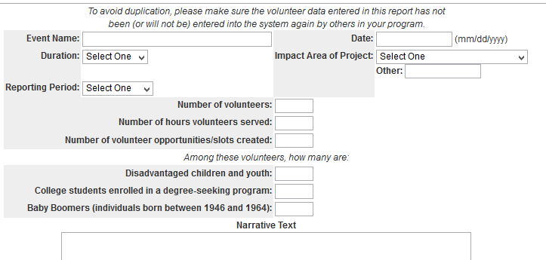
- If there is another JV AmeriCorps member at your agency who helped recruit volunteers, only the primary person recruiting/managing them should report.
- The Event is "August," (or whichever month you are reporting).
  - If you want to record specific one-time events and ongoing volunteer activities separately, please label “August – [Event Name]” or “August – OnGoing”
- For ongoing activities, the Date is the first date of the next month after the recruitment/management. For a one-time event, you can record the date for the day of the event.
- Duration: select “On-Going” or “One-Time” as appropriate.
- Impact Area: Choose the area that best fits. If your volunteers have an effect in more than one area, choose "Other" and explain further in the Narrative Text.
- Hours: Give the cumulative hours all volunteers served. For example, if 5 volunteers served for 2 hours, you would enter “10” into the hours section since every volunteer served for 2 hours each instead of just “2.” If you know how many hours each volunteer gave, please include it, but it's not required.
- Please fill in the Disadvantaged Youth, College Student and Baby Boomer information if you’re able to collect it!
- Please fill in information about the types of activities your volunteers did in the Narrative Text section. Remember, volunteers recruited and managed by you must also refrain from prohibited activities.
- Please ensure your volunteer tracking list is updated. See member webpage for more info.

Please Watch Your AmeriCorps language!! It's essential that, in case of an audit, none of your volunteer mobilization and recruiting reporting could be misinterpreted as "prohibited" AmeriCorps activities. This means no non-approved fundraising, other prohibited activities, or anything that sounds like employee displacement. Generic office activities such as answering phones and sitting at the front desk are often put into question when not framed in a way that describes how they support your specific program and its beneficiaries. For example, spending time at the front desk could be reported as directing clients to________ services.

