White Supremacist Culture
Spirituality Night Activity – Adapted from SURJ
Print out Guide, and List of White Supremacist Culture Characteristics for each person.
Purpose: To understand that racism is more than personal, that it is institutional and cultural, systemic and structural. To become more aware of how white supremacist culture impacts all of our lives and to figure out ways to interrupt and transform it.
Tonight we’re going to define and work with the concept of white supremacy culture
For the purposes of our discussion tonight, we’re going to define culture as the beliefs and values held by a group of people. Another way of thinking about culture is how a group of people define what is “normal” and what is “not normal.”
As the illustration indicates, the longer we swim in a culture, the more invisible it becomes. This is especially true when we live in a culture that has power to define reality for groups of people with different cultures.

What is culture?
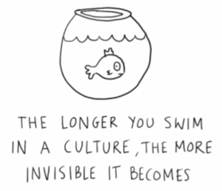
Culture refers to the knowledge, experience, beliefs, values, attitudes, meanings, hierarchies, religion, notions of time, roles, spatial relations, concepts of the universe, and material objects and possessions acquired by a group of people in the course of generations through individual and group striving.
Culture is the knowledge shared by a group of people.
Culture is communication, communication is culture.
A culture is a way of life of a group of people--the behaviors, beliefs, values, and symbols that they accept, generally without thinking about them, and that are passed along by communication and imitation from one generation to the next.
Culture is a collective programming of the mind that distinguishes the members of one group or category of people from another.
When we talk about mainstream culture or dominant culture, we are talking about the way those with power shape the values, beliefs, norms, and standards of a group. Dominant culture has the power to guide and shape reality through the lens it provides to shape the way we see the world. One way to identify dominant culture is to identify what we consider normal or to identify what we assume is true. For example, the dominant U.S. culture teaches us that the right to profit is more important than the rights of people to work for a living wage. Or to have adequate health care. Or good schools. Or a sustainable environment.

What is cultural racism?
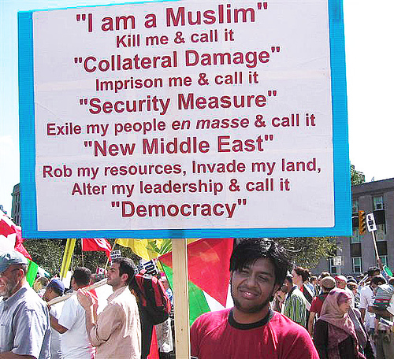

Cultural racism is how the dominant culture is founded upon and then shapes norms, values, beliefs and standards to advantage white people and oppress People of Color.
Cultural racism is how the dominant culture defines reality to advantage white people and oppress People of Color.
Cultural racism uses cultural differences to overtly and covertly assign value and normality to white people and whiteness in order to rationalize the unequal status and degrading treatment of People and Communities of Color.

Cultural racism is how the mainstream/dominant culture defines reality to advantage white people and oppress People of Color. Cultural racism reflects all the ways in which mainstream/dominant culture tells us that white people and whiteness are valuable and valued – safe, trustworthy, qualified, beautiful, deserving – and that People and Communities of Color are without value –dangerous, criminal, unqualified, undeserving, inhuman.
One of our most powerful cultural stories is that POC in general and Black people and communities in particular are dangerous and violent. Over and over again we can point to examples where white people have targeted, assaulted, and killed POC. The justification, often backed up by law, is that the Person or Community of Color posed a threat, even when that is clearly not the case.
**Discussion Question: Can you come up with another example of a widely held cultural norm that
perpetuates racism?

**Discussion Question: What is the purpose of function of cultural racism?
Some Possible Answers: A major purpose of cultural racism is to justify racist policies and procedures. Another purpose of cultural racism is to divide white people from POC, POC from other POC, white people from other white people, and all of us from ourselves.

What is white supremacy culture?
White supremacy culture is the idea (ideology) that white people and the ideas, thoughts, beliefs, and actions of white people are superior to People of Color and their ideas, thoughts, beliefs, and actions.
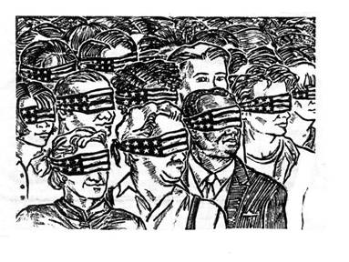
White supremacy culture is an artificial, historically constructed culture which expresses, justifies and binds together the United States white supremacy system. It is the glue that binds together white-controlled institutions into systems and white-controlled systems into the global white supremacy system.
​[from Sharon Martinas and the Challenging White Supremacy Workshop]

White supremacy culture is reproduced by all the institutions of our society. In particular the media, the education system, western science (which played a major role in reinforcing the idea of race as a biological truth with the white race as the "ideal" top of the hierarchy), and the Christian church have played central roles in reproducing the idea of white supremacy (i.e. that white is "normal," "better," "smarter," "holy" in contrast to Black and other People and Communities of Color.
**For a more in-depth discussion on "Why Black Lives Haven't Mattered: The Origins of Western Racism in Christian Hegemony," check out Paul Kivel's blog: https://christianhegemony.org/why-black-lives-havent-mattered-the-origins-of-western-racism-in-christian-hegemony For a more in-depth discussion on "The Doctrine of Discovery, Manifest Destiny, and American Exceptionalism," check out https://christianhegemony.org/the-doctrine-of-discovery-manifest-destiny-and-american-exceptionalism

- Depending on your sense of the group- exploring these resources at other spirituality nights might be useful…

***Discussion Question:
Why do we call it white supremacy culture? Can we call it something else?
Answer: This question comes up a lot when people plan to use the term white supremacy culture with their groups and organizations. There is a genuine concern that the term "white supremacy culture" will turn white people off, make them defensive and less willing to consider how this culture is reproduced. Part of this concern reflects how we've been taught by this culture to associate white supremacy with the Ku Klux Klan, neo-Nazis, and other people or groups that actively advocate a racist ideology and viewpoint. It is important to use the term "white supremacy culture" because the norms, values, and beliefs that our culture reproduces act to reinforce the belief that "white" and people attached to "whiteness" are better, smarter, more beautiful, and more valuable than "black," or people and communities indigenous to this land, brought here for the purpose of enslavement, or immigrating here from Asia, India, or south of our border. It is important to name what is really happening, which is that we live in a culture that reproduces -- sometimes overtly and sometimes very subtly -- the idea that white is supreme. Those of us who live in this culture, including those of us who fight against racism, swim in this culture (like the fish in the illustration above) and unintentionally and unwittingly reproduce these norms, values, and beliefs. One way to address the genuine concern is to explain why the phrase white supremacy culture is used to get people to think about it. While people may not be white supremacists, we are all swimming in and affected by a white supremacy culture.

White Supremacist Culture

Culture is powerful precisely because it is so present and at the same time so very difficult to name or identify. The characteristics listed below are damaging because they are used as norms and standards without being pro-actively named or chosen by the group and because they promote white supremacy thinking and behavior. We all live in a white supremacy culture, so these characteristics show up in the attitudes and behaviors of all of us – white people and People of Color. Therefore, the attitudes and behaviors described here can show up in any group or organization, whether it is white-led or predominantly white or People of Color-led or predominantly People of Color. For a more detailed description of these characteristics and their antidotes see: https://collectiveliberation.org/wp-content/uploads/2013/01/White_Supremacy_Culture_Okun.pdf

The list of white supremacy characteristics includes: perfectionism, a sense of urgency, defensiveness, valuing quantity over quality, worship of the written word, belief in only one right way, paternalism, either/or thinking, power hoarding, fear of open conflict, individualism, belief that I'm the only one (who can do this 'right'), the belief that progress is bigger and more, a belief in objectivity, and claiming a right to comfort.

Group Activity: Break into smaller groups (2-3 people) Go through the list of characteristics and pick out two to three that you see showing up in 1) JV house community, 2) your service sites, 3) your wider locale community. Discuss how these characteristics affect you in negative ways.

Come back to the larger group and share out. As a group choose one characteristic in each of the three areas (house, service, locale). Discuss what can be tangible plans to bring more awareness to this characteristic and how you can transform/interrupt it. Write this plan up so you can hold each other accountable- or check in with one another through the rest of the month.

If people are having a hard time choosing- or the list seems overwhelming- focus on perfectionism, either/or thinking, and right to comfort.

What do these look like:

Perfectionism shows up as: focusing on what’s wrong rather than what’s right,
confusing a mistake with being a mistake, blaming or shaming rather than
learning, focusing on others (you’re wrong) and focusing internally (I’m wrong),
unwillingness to take action for fear of “doing it wrong,” and micro-aggression
(micro-managing out of fear that others won’t do it “right.”

Antidotes: Develop a culture of appreciation: Develop a practice of identifying what we learn from our mistakes; Point out what is going well before what went wrong; Ask for specific ideas about how we might do something differently; Ask ourselves what the group needs; pay attention to morale and calling in; Ask ourselves what we need to allow for messiness and lack of closure

Either/or thinking shows up as: Good/bad, right/wrong, with us/against us;
Closely linked to perfectionism;
Inability to consider both/and or nuance;
Trying to make complex things simple;
Conflict and increased sense of (imposed) urgency;
Misuse of power by those with an agenda who think they are ‘right’

Antidotes: Notice when it shows up in our talk with each other and push for a wider range of alternatives; Notice when a sense of urgency arises and make space for moving more slowly and thoughtfully; Take a break so we can think more creatively; Avoid making decisions under extreme pressure (and plan for how to do that ahead of time); Consider a range of options and pick one knowing that it could be the wrong one (avoid “one right way” thinking); Remember to have a sense of humor

Right to comfort shows up as: Believing we have a right to emotional and
psychic safety; Blaming whoever is making us uncomfortable rather than
focusing on the problem being named; Equating our experience of unfairness
with systemic racism; Expecting the world to be fair (for and to us); Expecting
our feelings and questions to be addressed in our time frame and on our terms
so that we can feel better quickly; Expecting to be reassured when we are
uncomfortable

Antidotes: Understanding that discomfort is at the root of all growth and learning; Welcome it as much as we can, Talk to a trusted friend (who we know is ready and able to hold what we are feeling), Separate our feelings from what we do with our feelings (there are no wrong feelings); focus on thoughtful action; Avoid taking things personally; remember it is not about us; Take responsibility for our feelings

Additional Discussion Questions: Are there any other of these characteristics that are at play in your life that you would like to share with your community? How do these characteristics stand in the way of racial justice? What can you and your community do to shift the belief(s) and behavior(s) to ones that support racial justice?

Additional Resources:

For an article on white fragility (which functions to preserve white supremacy) and "why it's so hard to talk to white people about racism," https://goodmenproject.com/featured-content/white-fragility-why-its-so-hard-to-talk-to-white-people-about-racism-twlm/

For an article on 10 insidious ways white supremacy shows up in our everyday lives: https://everydayfeminism.com/2015/09/white-supremacy-everyday-life/

