White Supremacist Culture
Spirituality Night Activity- Adapted from SURJ
Purpose: To understand that racism is more than personal, that it is institutional and cultural, systemic and structural. To become more aware of how white supremacist culture impacts all of our lives and to figure out ways to interrupt and transform it.

What is culture?
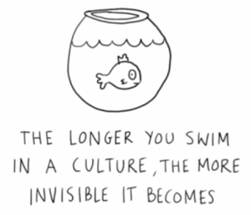
Culture refers to the knowledge, experience, beliefs, values, attitudes, meanings, hierarchies, religion, notions of time, roles, spatial relations, concepts of the universe, and material objects and possessions acquired by a group of people in the course of generations through individual and group striving.
Culture is the knowledge shared by a group of people.
Culture is communication, communication is culture.
A culture is a way of life of a group of people--the behaviors, beliefs, values, and symbols that they accept, generally without thinking about them, and that are passed along by communication and imitation from one generation to the next.
Culture is a collective programming of the mind that distinguishes the members of one group or category of people from another.

What is cultural racism?

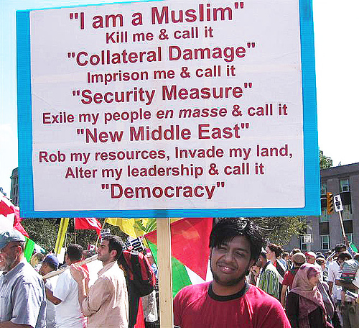
Cultural racism is how the dominant culture is founded upon and then shapes norms, values, beliefs and standards to advantage white people and oppress People of Color.
Cultural racism is how the dominant culture defines reality to advantage white people and oppress People of Color.
Cultural racism uses cultural differences to overtly and covertly assign value and normality to white people and whiteness in order to rationalize the unequal status and degrading treatment of People and Communities of Color.

What is white supremacy culture?
White supremacy culture is the idea (ideology) that white people and the ideas, thoughts, beliefs, and actions of white people are superior to People of Color and their ideas, thoughts, beliefs, and actions.
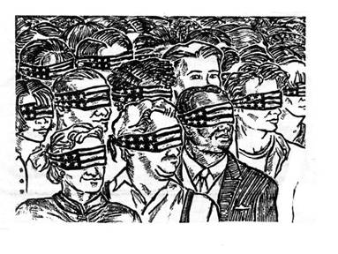
White supremacy culture is an artificial, historically constructed culture which expresses, justifies and binds together the United States white supremacy system. It is the glue that binds together white-controlled institutions into systems and white-controlled systems into the global white supremacy system.
​[from Sharon Martinas and the Challenging White Supremacy Workshop]

White supremacy culture is reproduced by all the institutions of our society. In particular the media, the education system, western science (which played a major role in reinforcing the idea of race as a biological truth with the white race as the "ideal" top of the hierarchy), and the Christian church have played central roles in reproducing the idea of white supremacy (i.e. that white is "normal," "better," "smarter," "holy" in contrast to Black and other People and Communities of Color.
**For a more in-depth discussion on "Why Black Lives Haven't Mattered: The Origins of Western Racism in Christian Hegemony," check out Paul Kivel's blog: https://christianhegemony.org/why-black-lives-havent-mattered-the-origins-of-western-racism-in-christian-hegemony For a more in-depth discussion on "The Doctrine of Discovery, Manifest Destiny, and American Exceptionalism," check out https://christianhegemony.org/the-doctrine-of-discovery-manifest-destiny-and-american-exceptionalism

White Supremacist Culture

Culture is powerful precisely because it is so present and at the same time so very difficult to name or identify. The characteristics listed below are damaging because they are used as norms and standards without being pro-actively named or chosen by the group and because they promote white supremacy thinking and behavior. We all live in a white supremacy culture, so these characteristics show up in the attitudes and behaviors of all of us – white people and People of Color. Therefore, the attitudes and behaviors described here can show up in any group or organization, whether it is white-led or predominantly white or People of Color-led or predominantly People of Color. For a more detailed description of these characteristics and their antidotes see: https://collectiveliberation.org/wp-content/uploads/2013/01/White_Supremacy_Culture_Okun.pdf
The list of white supremacy characteristics includes: perfectionism, a sense of urgency, defensiveness, valuing quantity over quality, worship of the written word, belief in only one right way, paternalism, either/or thinking, power hoarding, fear of open conflict, individualism, belief that I'm the only one (who can do this 'right'), the belief that progress is bigger and more, a belief in objectivity, and claiming a right to comfort.

Group Activity: Break into smaller groups (2-3 people) Go through the list of characteristics and pick out two to three that you see showing up in 1) JV house community, 2) your service sites, 3) your wider locale community. Discuss how these characteristics affect you in negative ways.

Come back to the larger group and share out. As a group choose one characteristic in each of the three areas (house, service, locale). Discuss what can be tangible plans to bring more awareness to this characteristic and how you can transform/interrupt it. Write this plan up so you can hold each other accountable- or check in with one another through the rest of the month.

Additional Discussion Questions: Are there any other of these characteristics that are at play in your life that you would like to share with your community? How do these characteristics stand in the way of racial justice? What can you and your community do to shift the belief(s) and behavior(s) to ones that support racial justice?

Additional Resources:

For an article on white fragility (which functions to preserve white supremacy) and "why it's so hard to talk to white people about racism," https://goodmenproject.com/featured-content/white-fragility-why-its-so-hard-to-talk-to-white-people-about-racism-twlm/

For an article on 10 insidious ways white supremacy shows up in our everyday lives: https://everydayfeminism.com/2015/09/white-supremacy-everyday-life/

