2017-2018

Direct Service Activity Reports
Direct Service Activity Reports need to be submitted EACH MONTH OF SERVICE to complement your timesheets! These reports are to be a 2-3 sentence summary of your JV AmeriCorps-related service activities for the month. These reports verify that you are doing service activities as outlined in your position description that steer clear from prohibited activities.

Here's how you submit direct service reports:

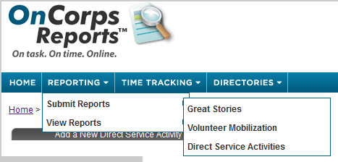

After you've logged into OnCorps, go to Reporting > Submit Reports > Direct Service Activities > Add a New Direct Service Activity.

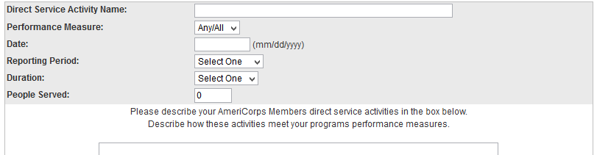
- The Direct Service Activity Name is simply called "August" (or whichever month you are reporting).
- Put in the Date.
- Add the number of People Served.
  - This should be an unduplicated count for the entire length of the year. That means, if you have served and counted clients/students/patients in August, they would not again be counted in September or later months. You only count ‘new’ clients each month.
- The Duration is monthly.
- From the Reporting Period menu, select Q1.
- THEN share a few lines of text about what JV AmeriCorps-related service activities you've been doing over the past month. This should be a brief overview of your service for the month- think 3 sentences! DON’T copy and paste the same text every month – we know different things happen!!
This is where you need to...WATCH YOUR LANGUAGE $##&%(%)$#%$!!!!!!!!

Watch Your AmeriCorps Language!! It's essential that, in case of an audit, none of your reporting could be misinterpreted as "prohibited" AmeriCorps activities. This means no non-approved fundraising, other prohibited activities, or anything that sounds like employee displacement. Generic office activities such as answering phones and sitting at the front desk are often put into question when not framed in a way that describes how they support your specific program and its beneficiaries. For example, spending time at the front desk could be reported as directing clients to________ services.

Other important AmeriCorps terms:

MEMBER not staff, employee, or volunteer
SERVICE not work or shift
PLACEMENT OR AGENCY not office, job, or workplace

