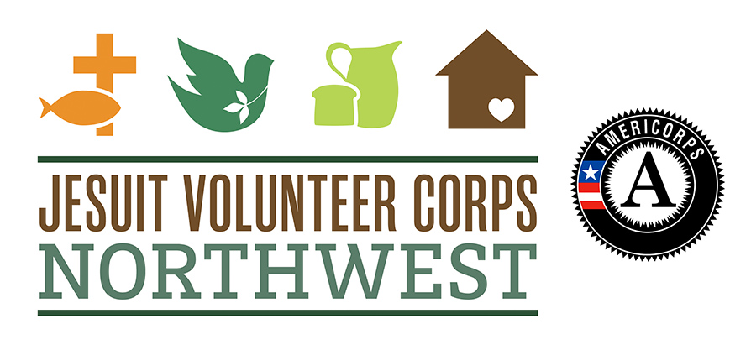

2017-18 JVC Northwest AmeriCorps Program: Classroom Teachers
Education Performance Measure – Spring Follow-Up Student Rating Form
Please complete the Spring Follow-Up Student Rating Form for all students who enrolled in your classroom in the fall, prior to November 1, 2016, and who have been in your classroom throughout the academic year. The form should be completed approximately two weeks before the end of the year.

Begin by transferring each student’s ID from the ID Linking Form to the rating form.

Once you have completed this Spring Follow-Up Student Rating Form for each of your students, please scan and email it to Rebecca Sutton-Kanyako, AmeriCorps Program Manager, at rsutton@jvcnorthwest.org.

Please do not return the ID Linking Form to JVC Northwest. Keep the ID Linking Form in a locked filing cabinet or other secure location where it will be inaccessible to others.

JV AmeriCorps Member:
Service Site:
Student ID Number:
Administration Date: | ____ /____ /____  Mo. / Day / Year

- Please rate this student on the following items by checking the box that best fits the student’s behavior.
Item | Very True | Sort of True | Not Very True | Not At All True
a. In my class, this student works as hard as he or she can.
b. This student comes to class unprepared.
c. When I explain new material, this student listens carefully.
d. In my class, this student does more than required.
e. This student actively participates in classroom activities.

- Over the past 10 school days, on how many days was the student absent from school? (DO NOT include sick days or excused absences.)
______ days
- Is there anything else you would like to note about this student or their academic engagement?

Items a, c, and d are from Student’s Achievement-Relevant Actions in the Classroom (SARAC): A Teacher-Report and a Self-Report Measure of Student Engagement vs. Disaffection in School. James G. Wellborn and James P. Connell (n.d.). Item b is from the RAPS-TE, the teacher-report measure from the Research Assessment Package for Schools, 1998 edition. Jesuit Volunteer Corps Northwest developed Item e.

