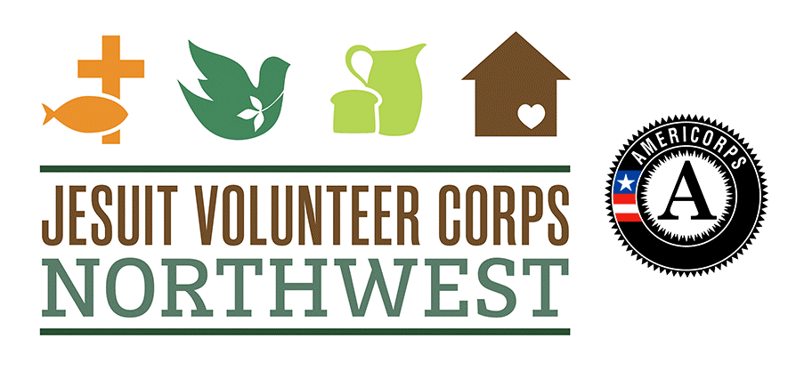
JV AMERICORPS MEMBER
IMPORTANT TASKS!
2017-2018

Ya gotta absolutely, positively, unequivocally, do the following for a successful service year!

17-18 JVC Northwest AmeriCorps Program Service Year Tasks

OnCorps Reporting - http://jvcnorthwest.oncorpsreports.com/
- Timesheets must be submitted and approved for each month of service to reach at least 1700 hours
  - Due by the 5th of each month
- Direct service activity reports must be submitted for each month of service
  - Due by the 5th of each month
- Volunteer mobilization reports must be submitted for each month of service, even if you do not mobilize/recruit volunteers. (Just put 0’s in the boxes and in the comments section, write “I do not manage volunteers)
  - Due by the 5th of each month
- One or more Great Story/Impact Snapshot must be submitted for the service year
  - Due by May 1

Performance Measures - Submit performance measure data for your assigned measure
- Capacity Building – Two capacity building projects must be completed and forms submitted. One Organizational Pre Assessment and one Organizational Post Assessment must be submitted.
  - Organizational Pre Assessment- due Nov. 10
  - Project 1 Planning Form- due Nov. 10
  - Project 1 Completion Form- due Feb. 16
    - Once completion form is submitted, JV must notify site supervisor to submit confirmation form
  - Project 2 Planning Form- due Feb. 16
  - Project 2 Completion Form- due May 18
    - Once completion form is submitted, JV must notify site supervisor to submit confirmation form
  - Organizational Post Assessment- May 31 (form available closer to due date)

- Education (Academic Support) - Monthly tracking forms must be emailed to AmeriCorps Program Manager, Rebecca Sutton-Kanyako at rsutton@jvcnorthwest.org, through service end with follow up rating forms due in April/May
  - Due by the 5th of each month

Education (Teacher & Academic Support) - Complete the Fall Baseline Student Rating Form and the Spring Follow Up Student Rating Form
  - Email forms to AmeriCorps Program Manager, Rebecca Sutton-Kanyako at rsutton@jvcnorthwest.org

- Health - Monthly tracking forms must be emailed to AmeriCorps Program Manager, Rebecca Sutton-Kanyako at rsutton@jvcnorthwest.org, through service end
  - Due by the 5th of each month

Evaluations - Your Site Supervisor will receive an evaluation form one month before form is due. You will need to fill out the form with them, sign, and date the document
- Mid-Term Evaluation submitted to AmeriCorps Program Manager by Friday February 16th
- Year-End Evaluation submitted to AmeriCorps Program Manager by:
  - Mid-May, if your term of service ends in May
  - Mid-June, if your term of service ends in June
  - Mid-July, if your term of service ends in July

Tasks to Compete at END OF THE YEAR in the AmeriCorps Portal to officially exit (https://my.americorps.gov/mp/login.do)
- Fill out your portion of the Exit Form and certify your hours of service
- Complete the AmeriCorps Member Exit Survey (this should be automatically prompted after you exit the portal and/or via your person email)

Resource Website – To access AmeriCorps related instructions and documents throughout your service year, please visit http://jvcnorthwest.org/jvresources. Password is NeverGiveUp

