Relevant Equity Timeline of the Pacific Northwest

Jesuit Volunteer Corps Northwest Orientation

Home is Where...

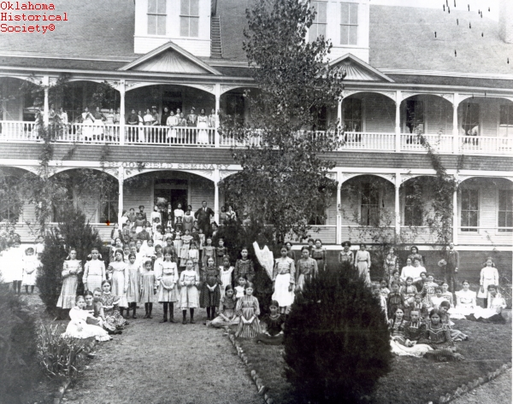

1819
Congress Creates Fund for “Civilization” of Indian Tribes

On March 3, 1819, the United States Congress enacted the Civilization Fund Act, funding an ongoing project where missionaries and church leaders partnered with the federal government to establish schools in Indian territories to teach Native children to replace tribal practices with Christian practices.

In 1824, the federal government established the Bureau of Indian Affairs to oversee the fund and implement programs to “civilize” the Native people.

In the following years, as the United States systematically removed tribes from their homelands to land west of the Mississippi River, the United States turned to policies purportedly aimed at achieving “the great work of regenerating the Indian race.”

According to Bureau Commissioner Luke Lea, it was “indispensably necessary that they be placed in positions where they can be controlled, and finally compelled by stern necessity...until such time as their general improvement and good conduct may supersede the necessity of such restrictions.”
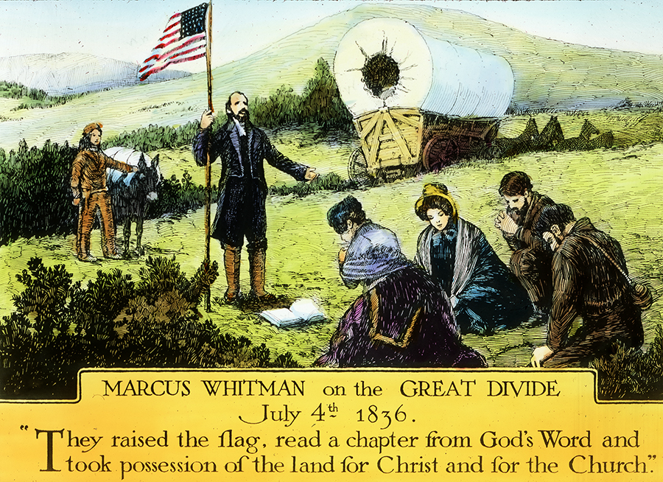

Mid-1800s
White Settlers in Oregon Territory

Explorers, trappers and military excursions in the Oregon Territory are soon followed by the first settlers: Christian missionaries.
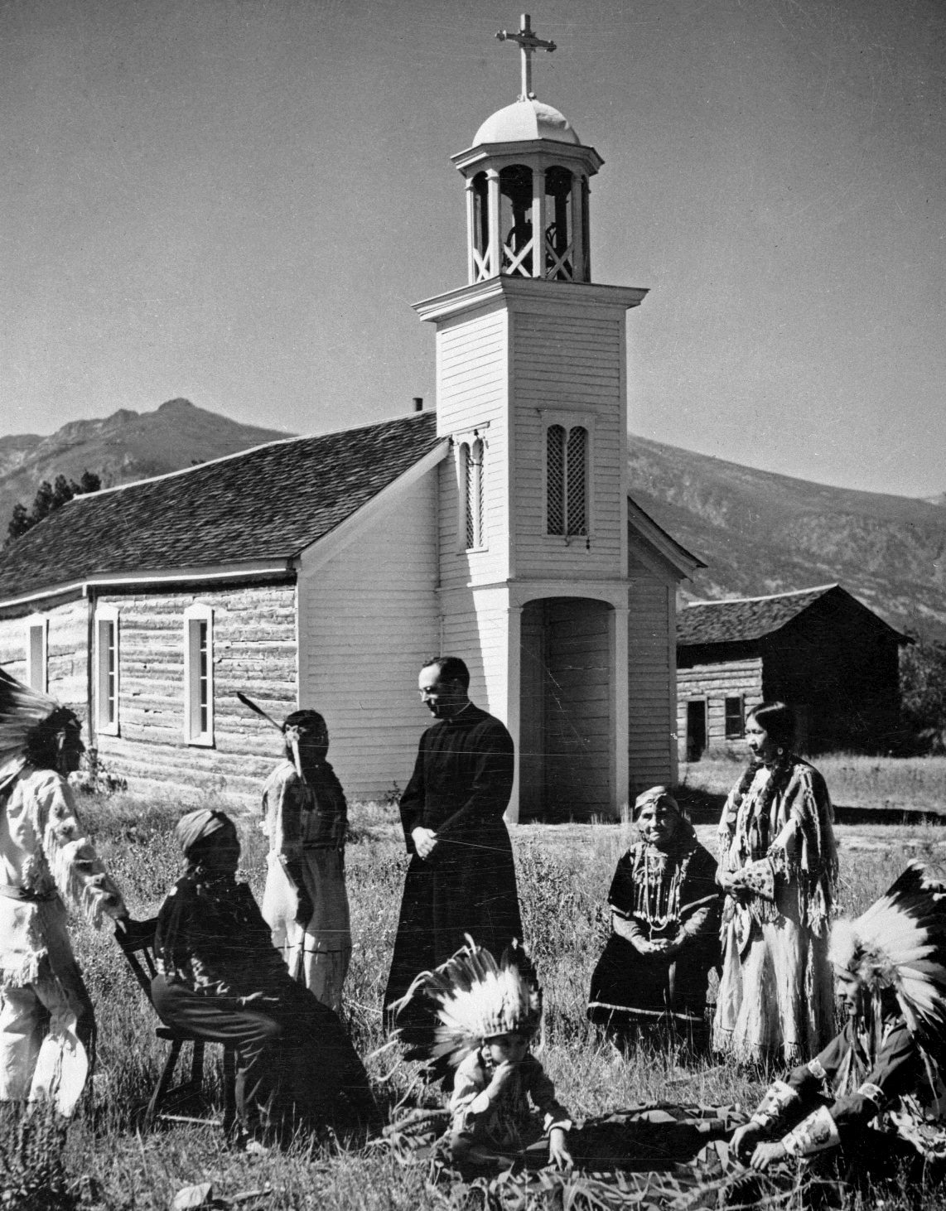

1840s
Jesuits in Montana

St. Mary Mission built by Jesuits in 1841, in what is now Stevensville, Montana, is the first permanent white settlement in Montana.
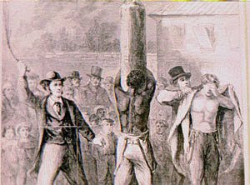

1844
Black Exclusion in Oregon Territory

The Provisional Government of Oregon enacts the region’s first exclusion law against Blacks. This law included the infamous “Lash Law,” which required that Black people—whether free or enslaved—be whipped twice a year “until he or she shall quit the territory.” This penalty is later changed to forced labor.

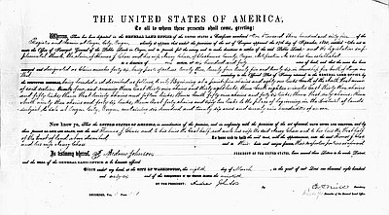

1850
Oregon Donation Land Claim Act

The Oregon Donation Land Act was enacted by the U.S. Congress to promote homestead settlement in the Oregon Territory; swelling the ranks of emigrants on the Oregon Trail. It granted 320 acres of free land to white males in the Oregon Territory. (The language of the act prevented non-Whites from claiming land in Oregon even if they had already settled here whether they had previous deeds to the land or not.) Claimants agreed to stay on and cultivate the land for 4 years to be granted immediate ownership.
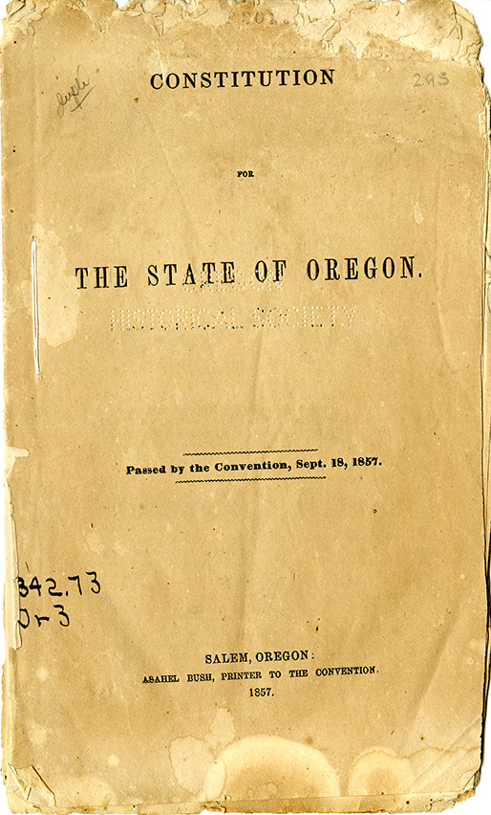

1857
Oregon Constitution

Oregon State Constitution banned any “free negro, or mulatto, not residing in this State at the time” from living, holding real estate and making any contracts within the state. This allowed Blacks to travel through the state, but banned them from living within it. The punishment was public whipping. Oregon is only state ever admitted to the union with such a clause. The phrase is not removed until 2000.
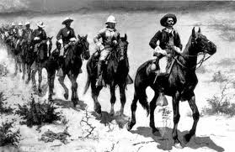

1840s-1870s
“Indian wars” in PNW

After the Oregon Treaty of 1846, through the end of the 1870s, dozens of armed conflicts ranged across the Pacific Northwest region as the US Government, churches and white settlers, spurred by the ideology of Manifest Destiny and quests for land and gold, sought to enclose and control land and resources of the region. Despite efforts of armed resistance and treaty by native communities, the US effort to colonize the region succeeded, resulting in decimation of native peoples, and removal of survivors to reservations.
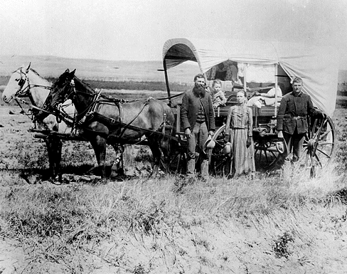

1862
American Homestead Act

The American Homestead Act allowed any white male over the age of 21 and a head of a family to claim up to 160 acres of land. He would improve it within five years or purchase the land at a small fee. The Homestead Act made 50 million acres of Indian land available to white homesteaders. It created the official policy for U.S. soldiers to wage war on the indigenous nations of the west to protect the white settlers encouraged to take their land.
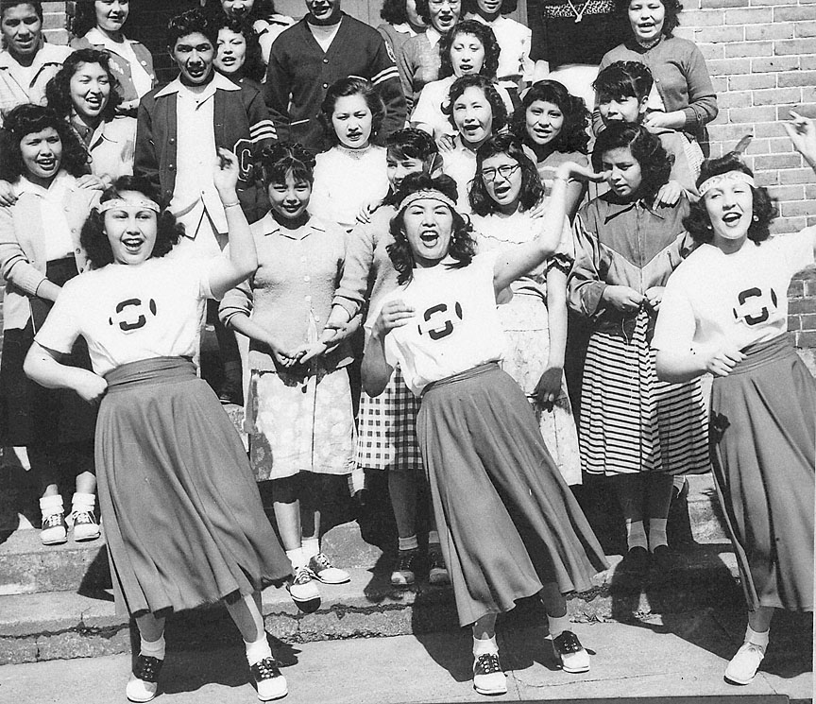

1879
Chemawa Indian Boarding School

Chemawa Indian Boarding School opened in Salem, Oregon as the third such boarding school in the nation. These schools were designed to assimilate Indian children into white culture and teach them vocational skills. Students were prohibited from speaking their tribal languages or practicing any of their traditional customs or culture. (This Indian School still operates in Salem, but without the extreme notions of assimilation of its original intent.)
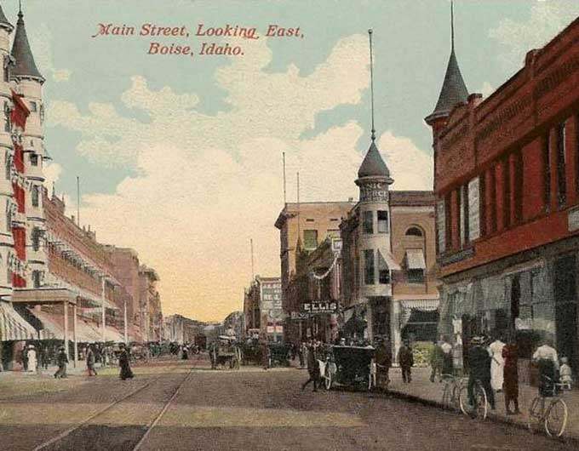

1886
Anti-Chinese Convention Boise, Idaho

Idaho public sentiment against Chinese immigrants, who made up about 30% of the population when Idaho became a state, culminated in an anti-Chinese convention held in Boise on February 25, 1886. At the convention, white residents of Idaho voted to expel Chinese citizens. In the decades following, white Idaho residents undertook a campaign of violent removal of Idaho’s Chinese population. Mobs frequently destroyed Chinese homes and businesses, and in 1887, a white mob murdered thirty-one Chinese miners in the Hell’s Canyon Massacre. By 1910, Idaho’s once-thriving Chinese population had nearly disappeared. Similar riots happened throughout the Northwest.
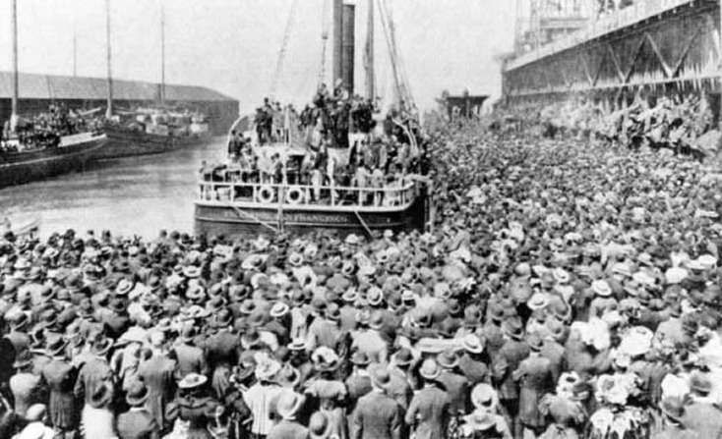

1888-1900
Gold Rushes & Homestead Act

Hundreds of thousands of gold prospectors and white settlers flood Alaska with support from Federal Government.
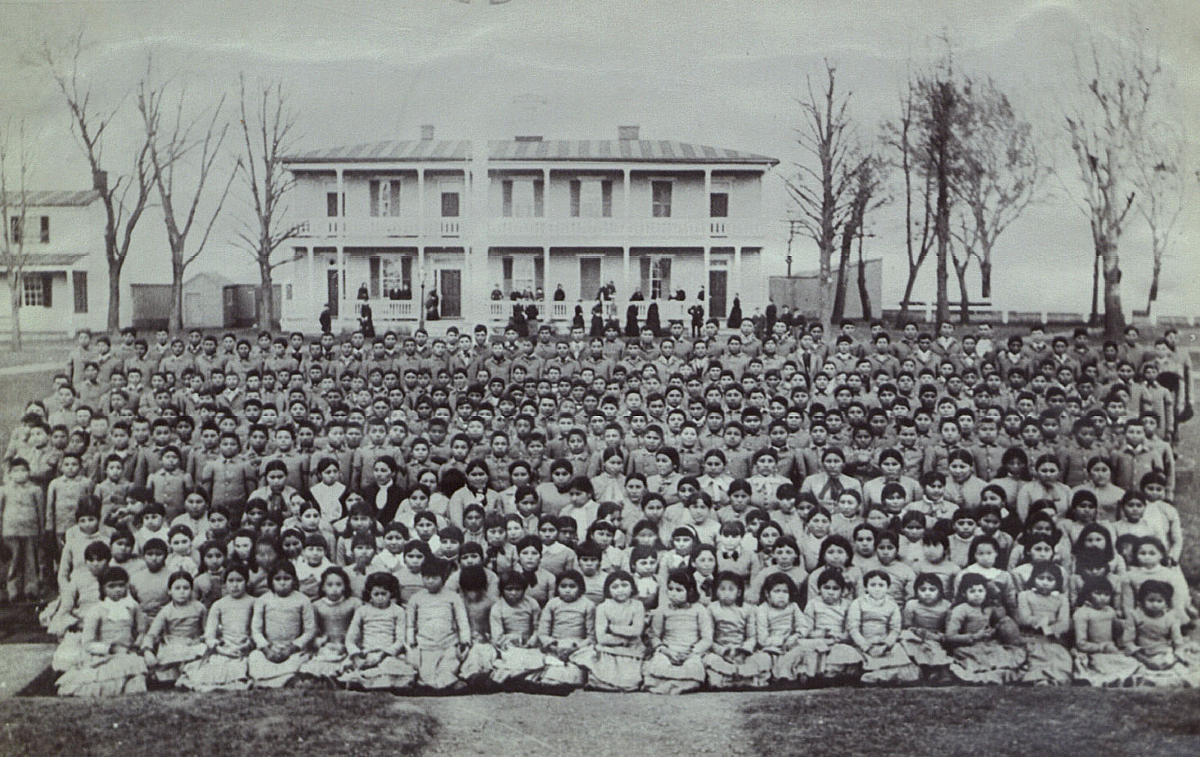

Late 1800s & Early 1900s
Native Boarding Schools

US Government policy swapped outright genocide of American Indians for forced assimilation into Western society. In order to accomplish this, educational policies were developed. First, boarding schools were established on and off reservations. In the west, and Alaska, government agency representatives often forcefully took children away to boarding schools hundreds and even thousands of miles away from their homeland. This educational policy was an attempt to assimilate and acculturate indigenous children into Western culture, and America’s “melting pot”. Boarding schools needed to be far enough away to discourage families from easily visiting their children, since family members would only hinder and detract from the goals of assimilation. The educational policy was also aided and abetted by many of America’s religious communities, which had begun to establish boarding schools of their own.
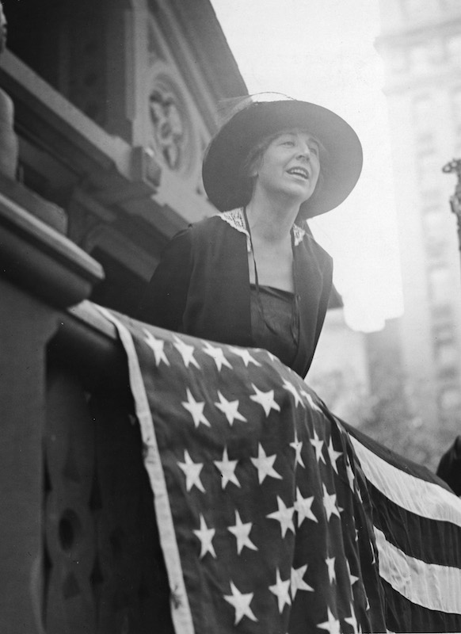

1916
Jeannette Rankin elected to House of Representatives

Two years after women are allowed to vote in Montana, Jeannette Rankin takes her seat as the first woman to serve in Congress, four years before national suffrage.
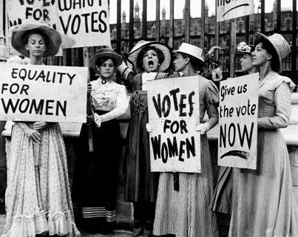

1920
19th amendment

White women win the right to vote. While the 19th amendment is often cited as “giving women the right to vote”, in reality the only group that won that right with its passage were white women.
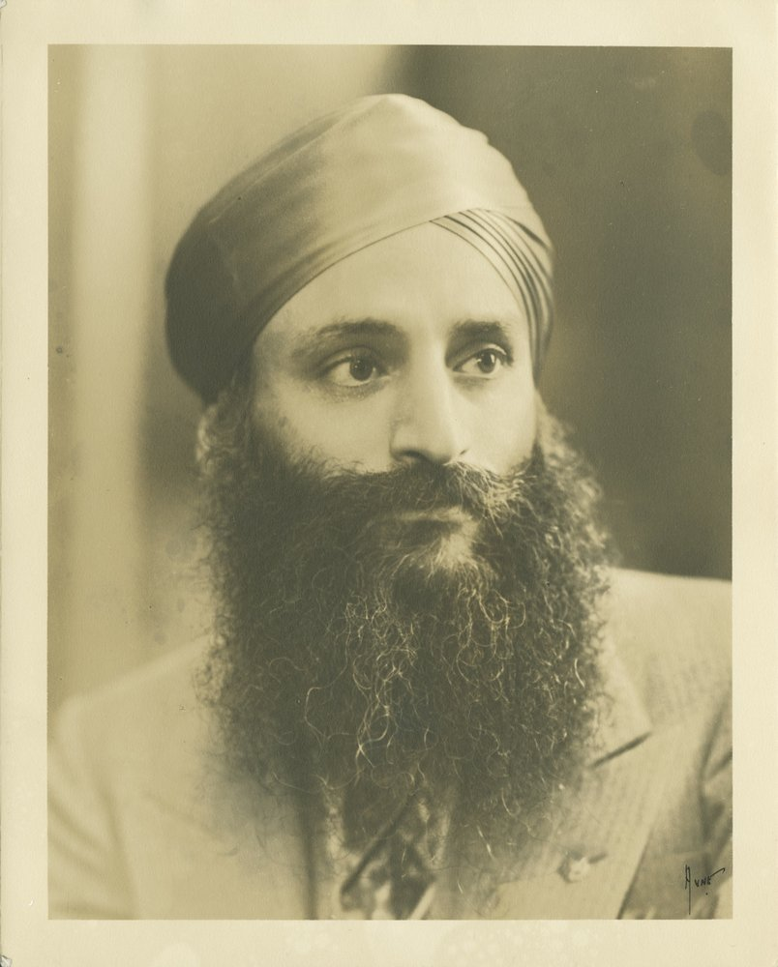

1923
Color of Skin determines Citizenship

An Oregon WWI veteran was denied U.S. citizenship. The U.S. Supreme Court unanimously ruled that Bhagat Singh Thind could not be a naturalized citizen. Anthropologists defined people of India as belonging to the Caucasian race. A previous ruling (United States v. Ozawa) had affirmed that immigration law referring to “white" meant “Caucasian” as it applied to denying citizenship to light skinned Japanese immigrants. In this case, Justice Sutherland argued that the "common man's" definition of “white” did not correspond to all "Caucasians". Even though Indians were considered “Caucasian” they were not “white”. Therefore they could not be naturalized. Thus the color of skin became the legal qualification for citizenship. The decision had a significant impact. Many Indians who had previously obtained U.S. citizenship in the United States now had their citizenship revoked, and lost many rights and privileges as a result. In California, the 1913 Alien Land Act barred non-citizens from owning land, and Indian Americans in the state who lost their citizenship also lost their land. Following the Thind decision, America’s Indian population dropped by half.
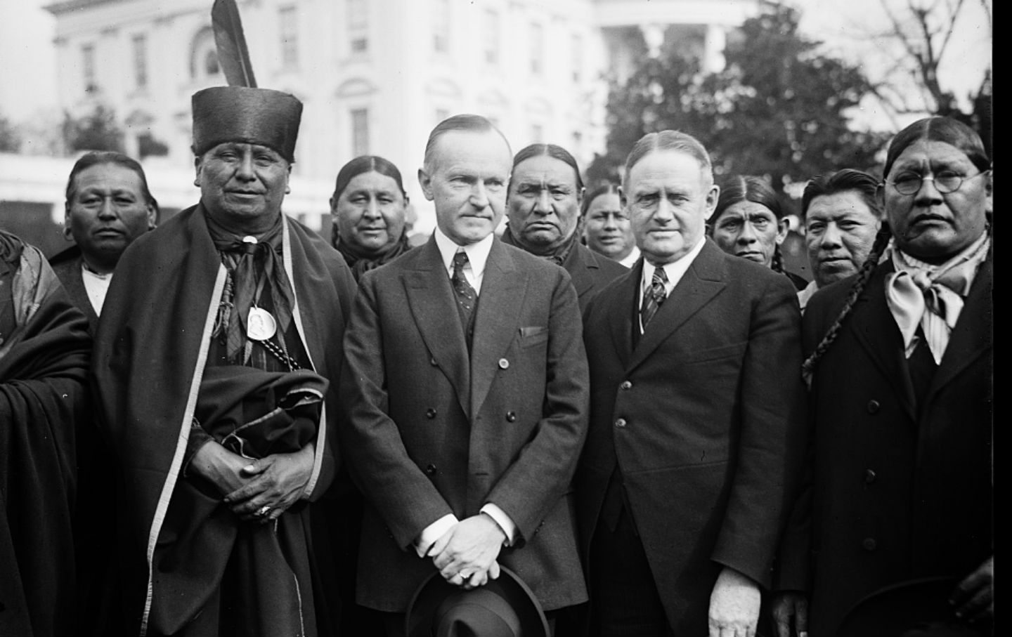

1924
Indian Citizenship act

The Act grants Native Americans citizenship for the first time, but many western states refuse to allow them to vote. Some of the tactics used to discourage voting includes physical violence, destruction of property, economic pressures, poll taxes, hiding the polls and reading requirements.
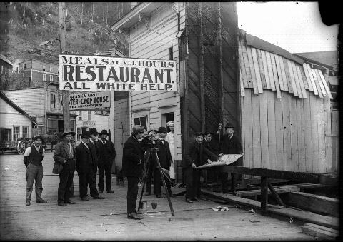

1925
Voter Literacy Law in Alaska

The seventh Alaska Territorial Legislature enacted into law a measure requiring that voters in territorial elections be able to read and write the English language. The law is just one part of what is known as “Jim Crow in Alaska”.
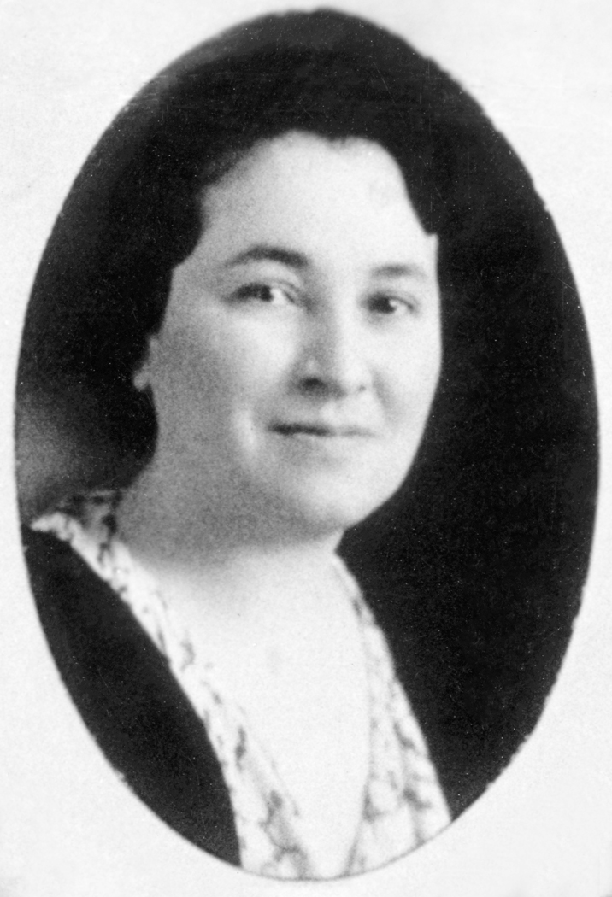

1932
Dolly Cusker Akers takes her seat

Dolly Cusker Akers was the first Native American elected to the Montana House of Representatives. Akers, active in tribal politics, was the only woman elected to the legislature in 1932. She chaired the Federal Relations Committee that handled Indian affairs. She also oversaw passage of legislation that allowed Indians to send their children to schools run by their own communities and not by the government.
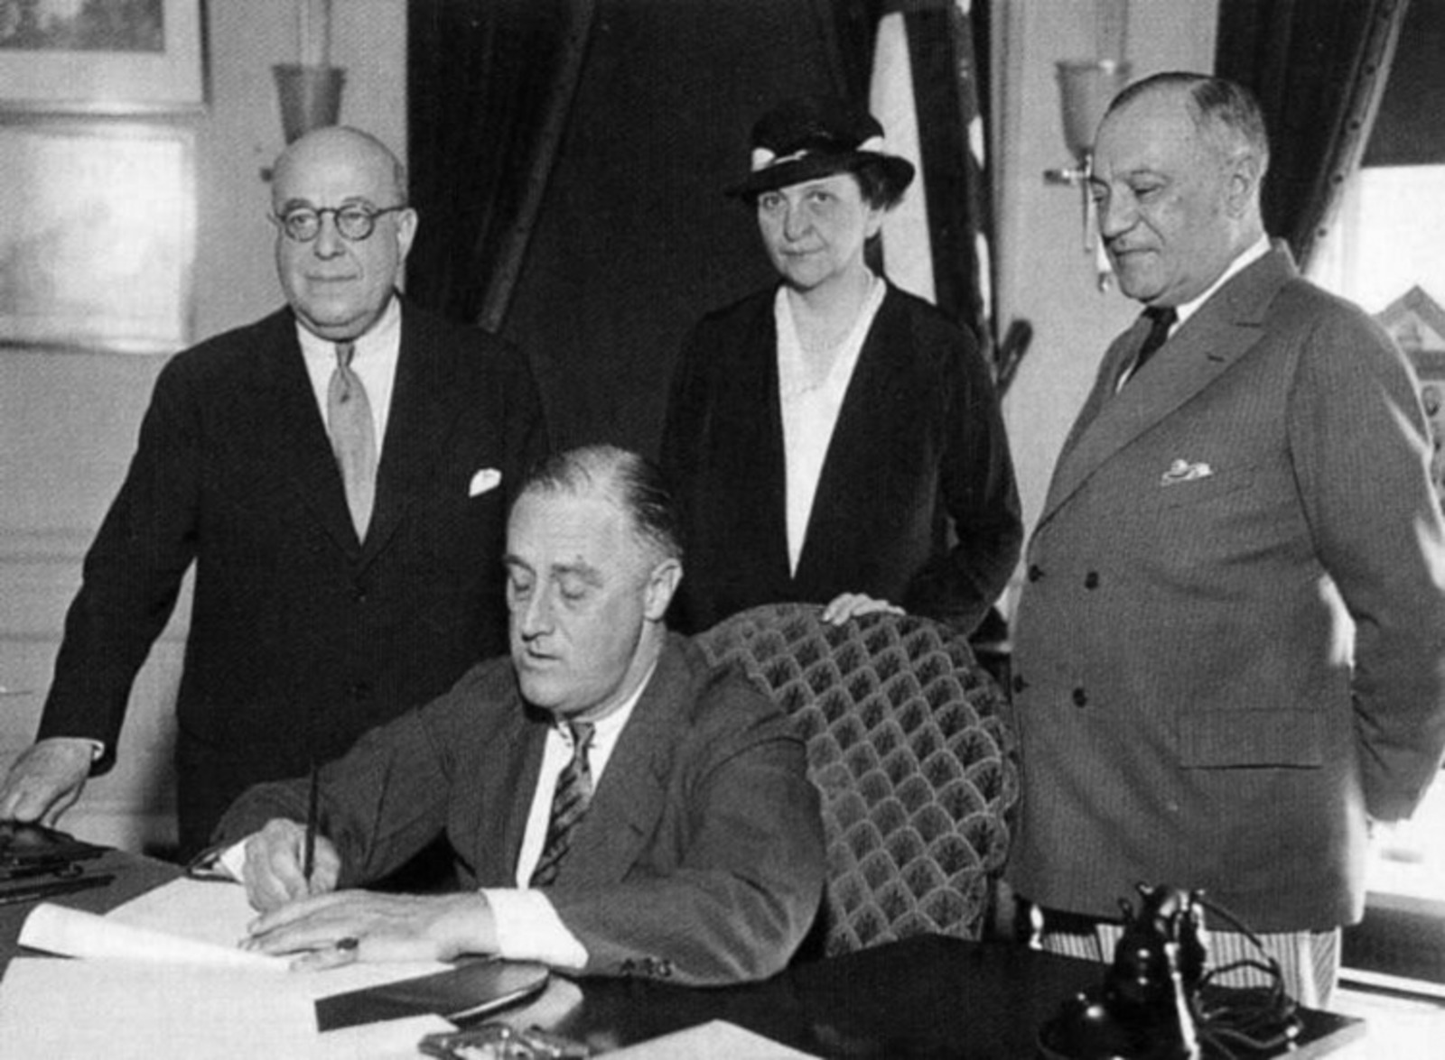

1935
National Labor Relations Act

The NLRA establishes the legal framework workers organizing into labor unions, providing some protections for organizing activity. The act excludes agricultural and domestic workers – groups that were then, and are now, overwhelmingly Black, brown and immigrant – from those protections and the long-term benefits of improved wages, benefits and working conditions derived from union organizing.

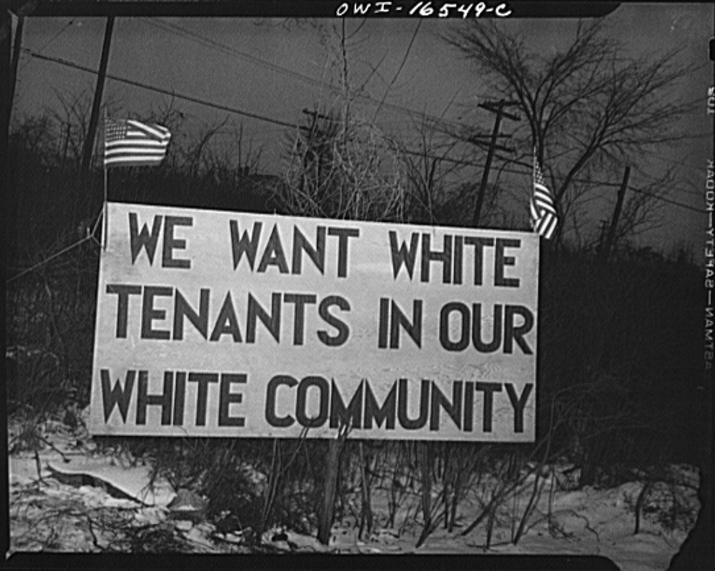

Early 1940s
Redlining: Housing Discrimination

In the Northwest and across the US, redlining is the combination of practices that segregates communities by race. Sometimes involving drawing actual red lines on a map, these practices include denying services, preferential lending, re-direction of buyers, and outright bigotry to maintain whites-only neighborhoods and areas. The practice shaped the segregation and demographic patterns of cities across the US.
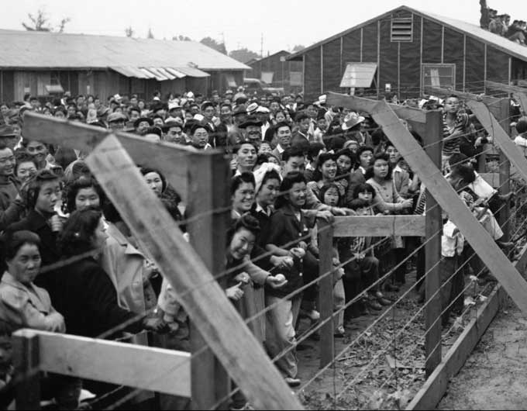

1942
Japanese Internment

After the attack on Pearl Harbor, all persons of Japanese heritage living in the western United States were forced to move to camps by the Wartime Civil Control Administration. More than 4,500 Japanese Americans from western Oregon were sent to internment camps: 2/3 were American citizens. 110,000 to 120,000 people interned in all on the West Coast.
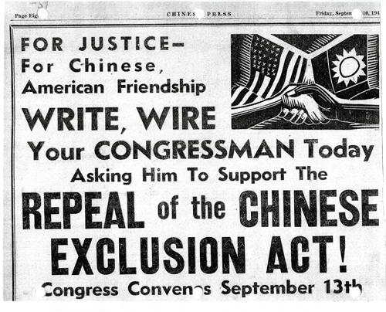

1943
Chinese Exclusion Act is repealed

Individuals of Chinese descent became eligible for citizenship and the right to vote. The exclusion act had been signed in 1882 and was originally intended to last for 10 years, but was renewed and then made permanent by 1902. It had been the first law implemented to prohibit an specific ethnic group from entering the United States.
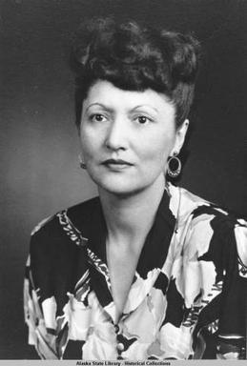

1945
Alaska Anti-Discrimination Act

Championed by Native Alaskan (Tlingit) civil rights activist Elizabeth Peratrovich, the Alaska Anti-discrimination Act was the first post-Civil War civil rights bill passed in a US state. The act declared equal access for all citizens to businesses, public spaces and transportation and provided for jail sentences and fines for violations.

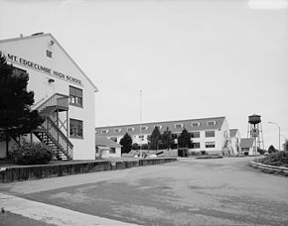

1946
Mt.Edgecumbe High School

Boarding school for native high school students opens in Sitka, AK. The school was originally operated by the federal Bureau of Indian Affairs (BIA) as part of a network of boarding high schools, which included schools in Eklutna and Wrangell. After several decades of operation by the BIA, the school was briefly closed in the 1980s before being reopened by the Alaska Department of Education, which operates it today. The school remains one of the only educational opportunities for students in rural communities.

1950s & 60s
Interstate Highway System built

Federal planning places construction of the new highway system, and especially it’s key interchange points and ramps, in poor communities, mostly of color, in cities across the country. In Portland and Seattle, as in many other major cities, Black and other communities of color are displaced and the physical integrity of neighborhoods and communities are destroyed in the name of progress.

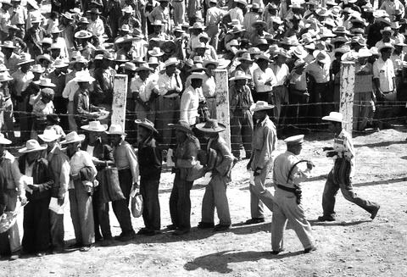

1954
Operation Wetback Nationwide

“Operation Wetback” targets Mexican American communities for “illegal immigrants” and deports more than 3.8 million people to Mexico.
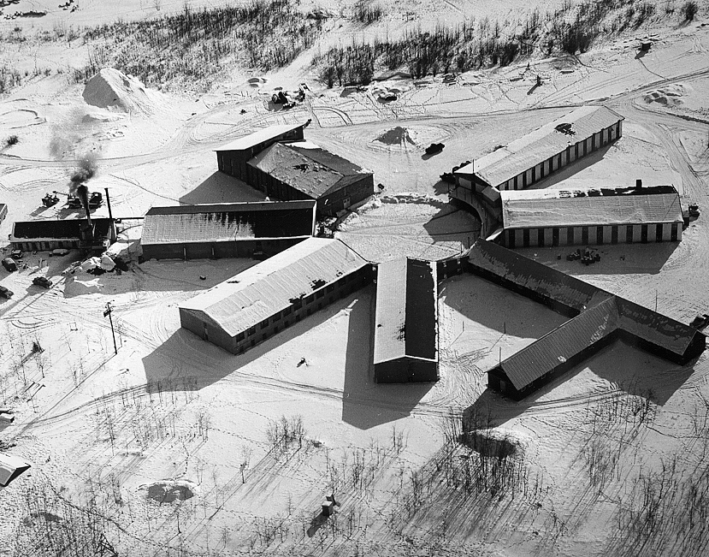

1956
Jesuits open Copper Valley Boarding School for Alaska Natives

Jesuits from the Oregon Province of the Society of Jesus and the Sisters of Saint Ann formed a partnership to open the Copper Valley school—a boarding school for Native Alaskan children— near Glennallen, Alaska. Lay volunteers, mostly engineering students from Gonzaga University, were brought into Alaska to teach at the school. These were the first recruits of what became the Jesuit Volunteer Corps.

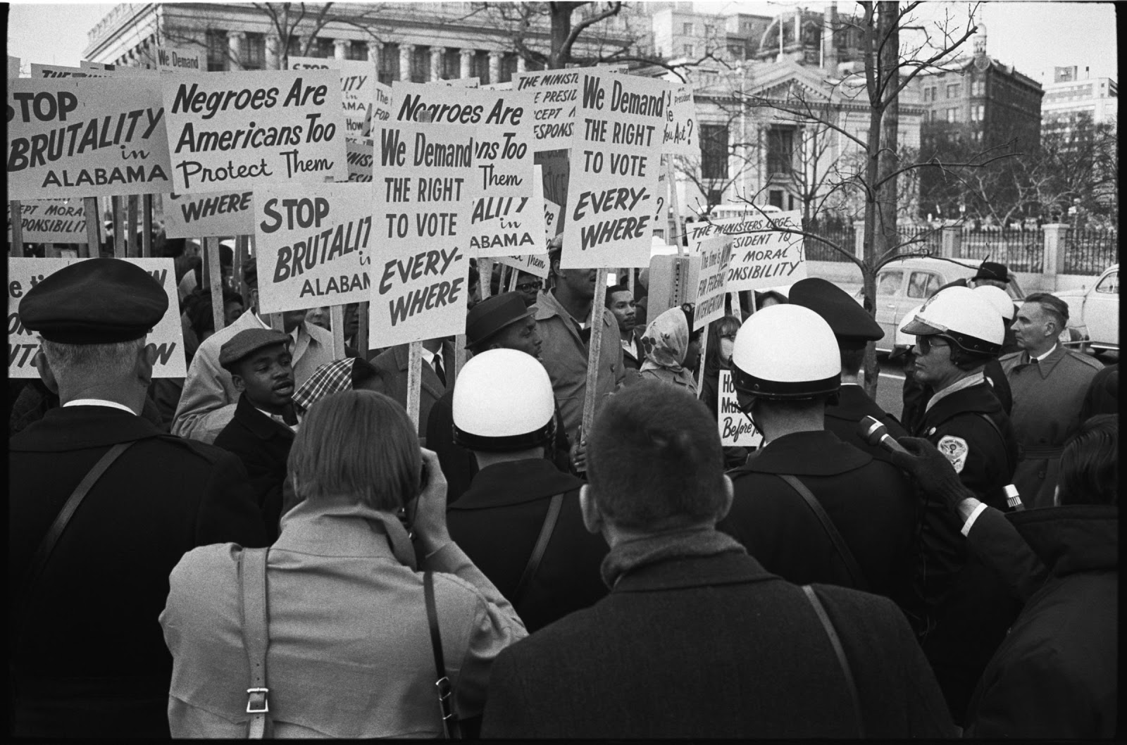

1965
Voting Rights act of 1965

The Civil Rights Movement wins a major victory when Lyndon Johnson signs the Voting Rights Act into law. It bans literacy tests in the Deep South and provides federal enforcement of black voter registration and voting rights. This Act affects Virginia, Alabama, Georgia, Louisiana, Mississippi, North Carolina, and South Carolina. It also applies in Alaska.
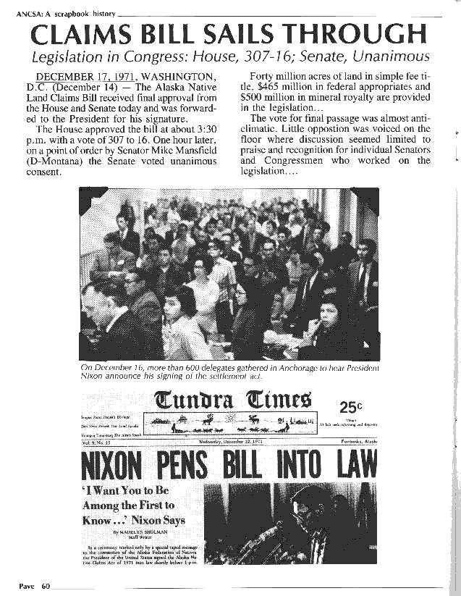

1971
Alaska Native Claims Settlement Act

Transfers ownership of 44 million acres of land to newly established native corporations. it included provisions that had never before been attempted in previous United States settlements with Native Americans. The newly passed Alaska Native Claims Settlement Act created twelve Native regional economic development corporations. Each corporation was associated with a specific region of Alaska and the Natives who had traditionally lived there. This innovative approach to native settlements engaged the tribes in corporate capitalism.
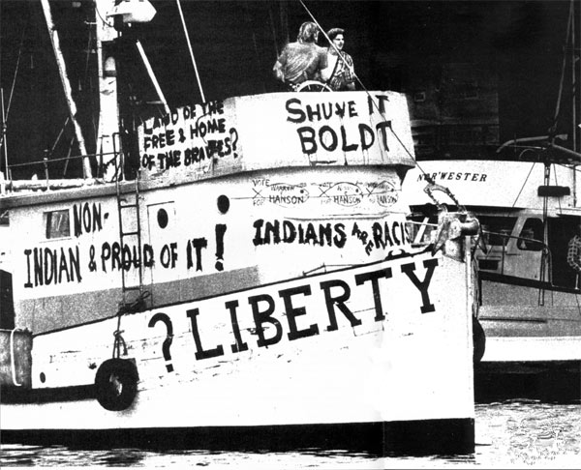

1974
Boldt Decision

Federal Judge George Boldt (1903-1984) issues an historic ruling reaffirming the rights of Washington's Indian tribes to fish in accustomed places. The "Boldt Decision" allocates 50 percent of the annual catch to treaty tribes, which enrages other fishermen.

At the same time Judge Boldt denies landless tribes -- among them the Samish, Snoqualmie, Steilacoom, and Duwamish -- federal recognition and treaty rights...Judge Boldt finally held that the government's promise to secure the fisheries for the tribes was central to the treaty-making process and that the tribes had an original right to the fish, which they extended to white settlers. It was not up to the state to tell the tribes how to manage something that had always belonged to them. Judge Boldt ordered the state to take action to limit fishing by non-Indians.

The Boldt Decision revolutionized the state fisheries industry and led to violent clashes between tribal and non-tribal fishermen and regulators. In 1975, the Ninth Circuit Court of Appeals upheld Boldt's ruling, and on July 2, 1979, the U.S. Supreme Court largely affirmed it. Principles established by the Boldt Decision have since been applied to other resources, including shellfish.
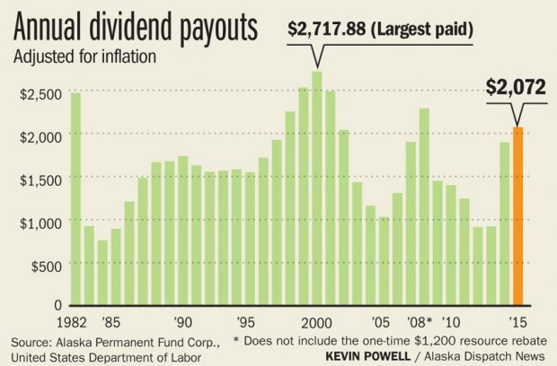

1976
Alaska Permanent Fund

Voters approve this constitutional amendment establishing the Alaska Permanent Fund to receive "at least 25 percent" of all state oil revenues and related income. The Permanent Fund Dividend [PFD] is a dividend paid to Alaska residents that have lived within the state for a full calendar year (January 1 – December 31), and intend to remain an Alaska resident indefinitely. The first permanent fund distribution was $1000. The lowest individual dividend payout was $331.29 in 1984 and the highest was $2,072 in 2015.
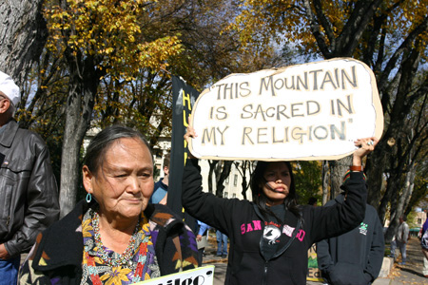

1978
American Indian Religious Freedom Act

The American Indian Religious Freedom Act (commonly abbreviated to AIRFA) is a US federal law and a joint resolution of Congress that was passed in 1978. It was created to protect and preserve the traditional religious rights and cultural practices of American Indians, Eskimos, Aleuts and Native Hawaiians. These rights include, but are not limited to, access of sacred sites, repatriation of sacred objects held in museums, freedom to worship through ceremonial and traditional rites, including within prisons, and use and possession of objects considered sacred. The Act required policies of all governmental agencies to eliminate interference with the free exercise of Native religion, based on the First Amendment, and to accommodate access to and use of religious sites to the extent that the use is practicable and is not inconsistent with an agency's essential functions. It also acknowledged the prior violation of that right.
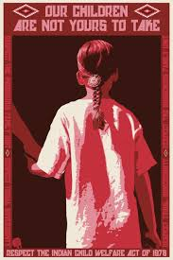

1978
Indian Child Welfare Act

The Indian Child Welfare Act (ICWA) was enacted in 1978 in response to a crisis affecting American Indian and Alaska Native children, families, and tribes. Studies revealed that large numbers of Native children were being separated from their parents, extended families, and communities by state child welfare and private adoption agencies. In fact, research found that 25%–35% of all Native children were being removed; of these, 85% were placed outside of their families and communities—even when fit and willing relatives were available.
Congressional testimony documented the devastating impact this was having upon Native children, families, and tribes. The intent of Congress under ICWA was to “protect the best interests of Indian children and to promote the stability and security of Indian tribes and families” (25 U.S.C. § 1902). ICWA sets federal requirements that apply to state child custody proceedings involving an Indian child who is a member of or eligible for membership in a federally recognized tribe.
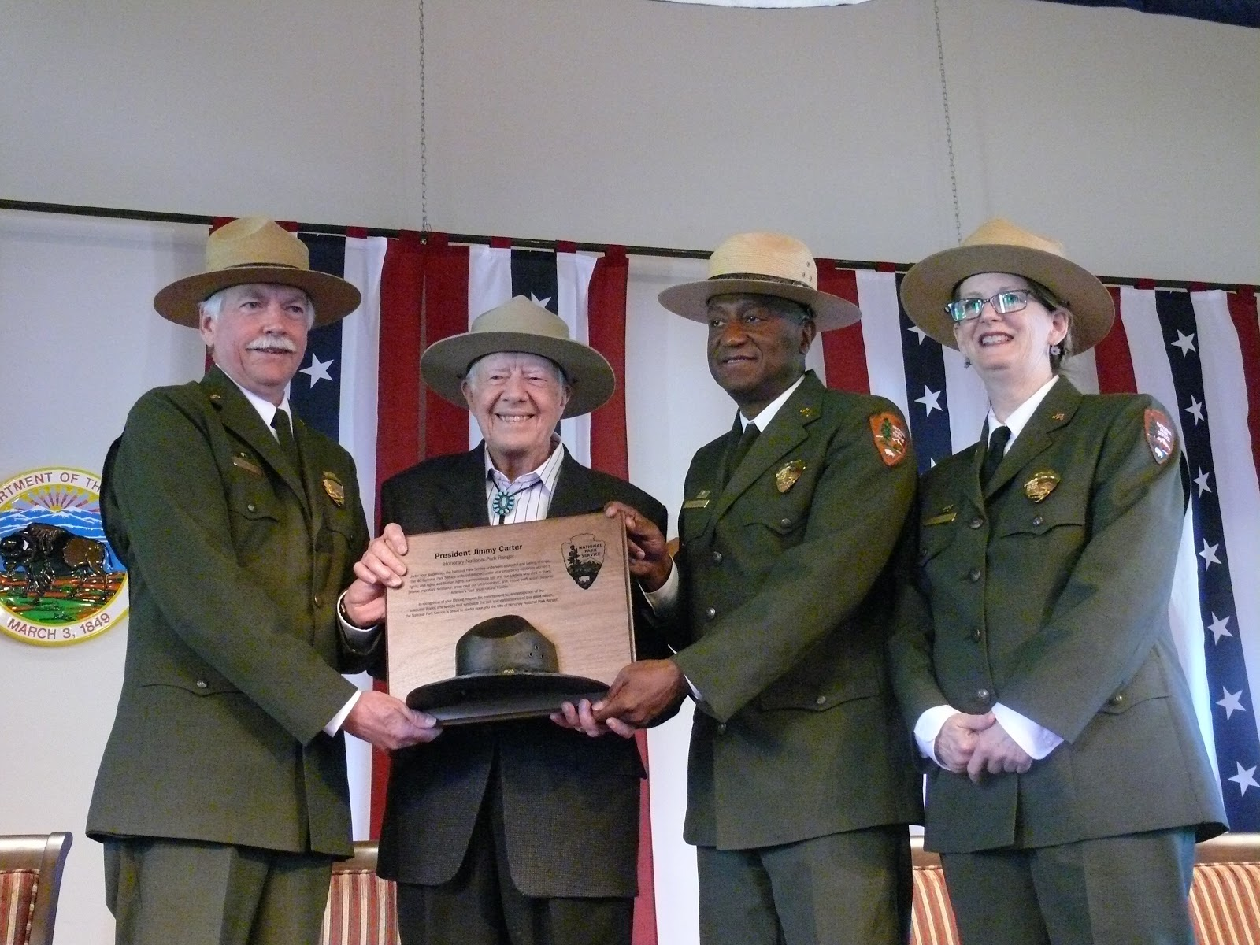

1980
Alaska National Interest Lands Conservation Act

ANILCA creates a huge public lands system in Alaska. Over 100 million acres are set aside for preservation and protection throughout Alaska.
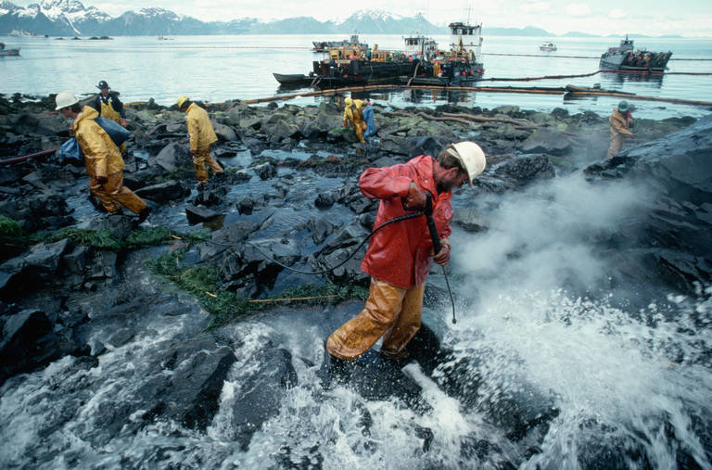

1989
Exxon Valdez Oil Spill

An oil tanker known as the Exxon Valdez runs into a reef in the Prince William Sound, spilling 11 million gallons of oil along 1,500 miles of coastline. A massive cleanup begins, lasting more than three years.
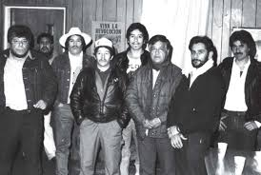

1980’s
Latinx Population Grows

Between 1980 and 1990, the Latino population in Oregon grew by 70 percent. Most lived in cities, with only 33 percent living in rural areas. In 1985 Farmworker advocacy groups like Pineros y Campesinos Unidos del Noroeste (Northwest Tree Planters and Farm Workers United, known as PCUN) in Woodburn, OR and United Farmworkers of Washington State in central Washington were created to protect workers’ rights and fight abuses such as extremely low wages and inhumane living conditions. In addition, as the Latino population increased in Oregon and elsewhere, new challenges appeared in attempts to pass English-only legislation and deny civil and political rights to undocumented immigrants.
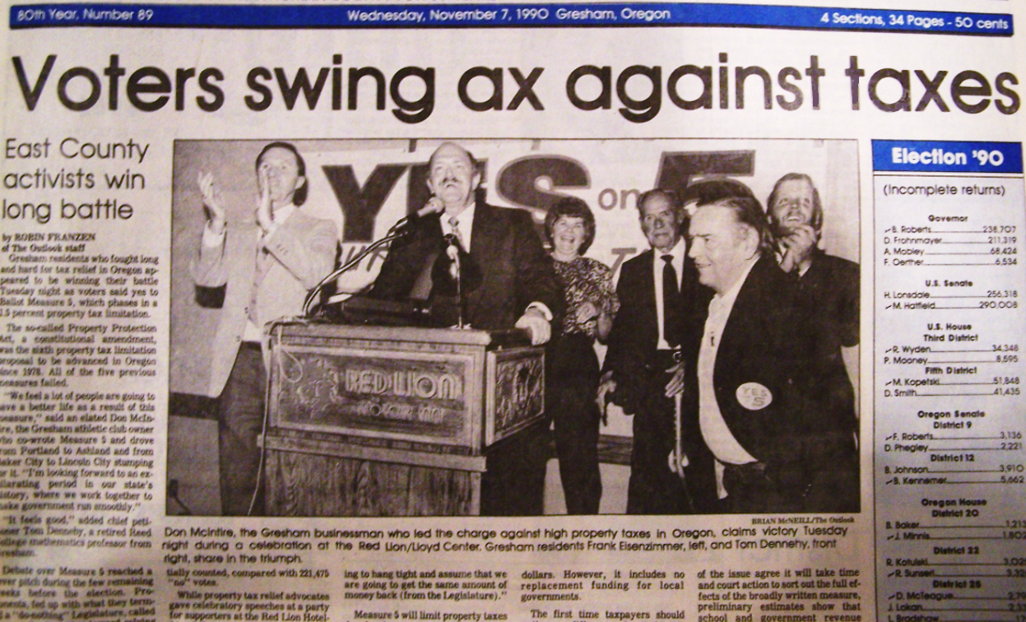

1990
Measure 5- Oregon

Passed by margin of 50k votes, out of 1 million votes cast. Devastated school funding across state.
While eliminating local property tax funding of schools, the funding crisis created community fundraising at the school level, which increased disparities because schools in wealthy communities have access to much larger pools of money in their student’s families, while poor communities and communities of color are left struggling with under-funded schools.
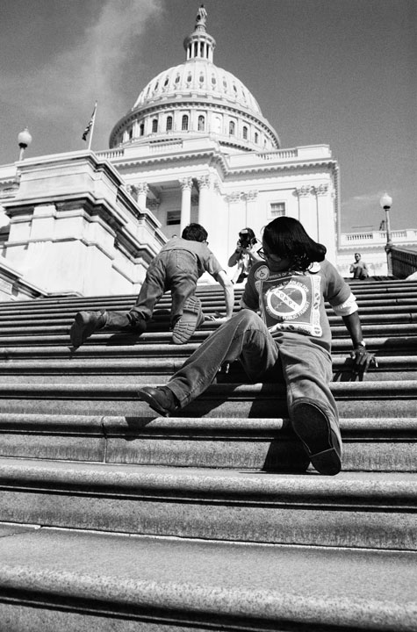

1990
Americans with Disabilities Act

The ADA is a wide-ranging civil rights law that is intended to protect against discrimination based on disability. It affords similar protections against discrimination to Americans with disabilities as the Civil Rights Act of 1964, which made discrimination based on race, religion, sex, national origin, and other characteristics illegal. In addition, unlike the Civil Rights Act, the ADA also requires covered employers to provide reasonable accommodations to employees with disabilities, and imposes accessibility requirements on public accommodations. The ADA was the result of decades of social justice activism, including protests, sit-ins, lobbying and direct action by disability rights activists that won incremental victories before winning the passage of the ADA.
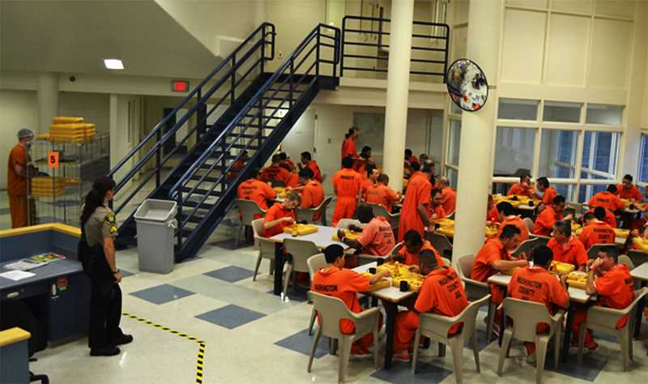

1994
Measure 11 Oregon

Mandatory minimum sentencing law: The sentencing judge cannot give a lesser sentence than that prescribed by Measure 11, nor can a prisoner’s sentence be reduced for good behavior. Prisoners cannot be paroled prior to serving their minimum sentence.

Youth of color comprise 25% of the youth population but 36% of the youth indicted under Measure 11. Black Youth: 4% of the youth population, 19% of the Measure 11 indictments. After they are arrested, black youth are almost three times as likely to face a Measure 11 indictment.
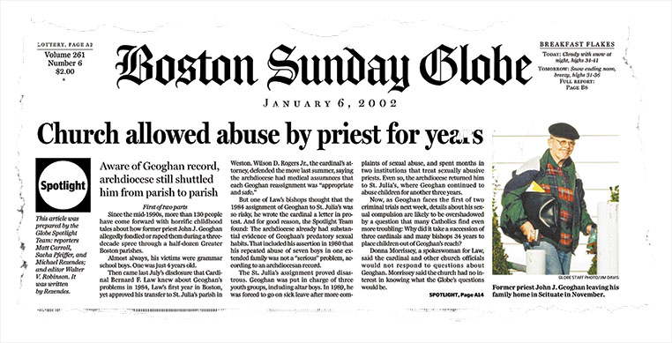

2002
Boston Globe breaks priest abuse story

Accusations had received attention since the 1980s, in the US and around the world, but the Boston Globe story was the tipping point for widespread coverage and conversation in the US. From 2001 to 2010 the Holy See, the central governing body of the Catholic Church, considered sex abuse allegations concerning about 3,000 priests dating back up to fifty years.

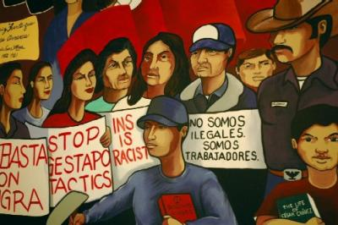

2000’s
Latinx Community Continues to Grow

In the twenty-first century, Latinos make up about 12% of Oregon and Washington’s population, making them the largest minority. Of those who identify as Latinos, 63 percent were born in the United States. In Oregon, 85 percent of Latinos are of Mexican origin, with the remaining 15 percent primarily from Guatemala, Puerto Rico, Cuba, El Salvador, and the Dominican Republic. According to the Pew Hispanic Center, unauthorized immigrants comprised roughly 5 percent of Oregon and Washington’s workforce in 2014.
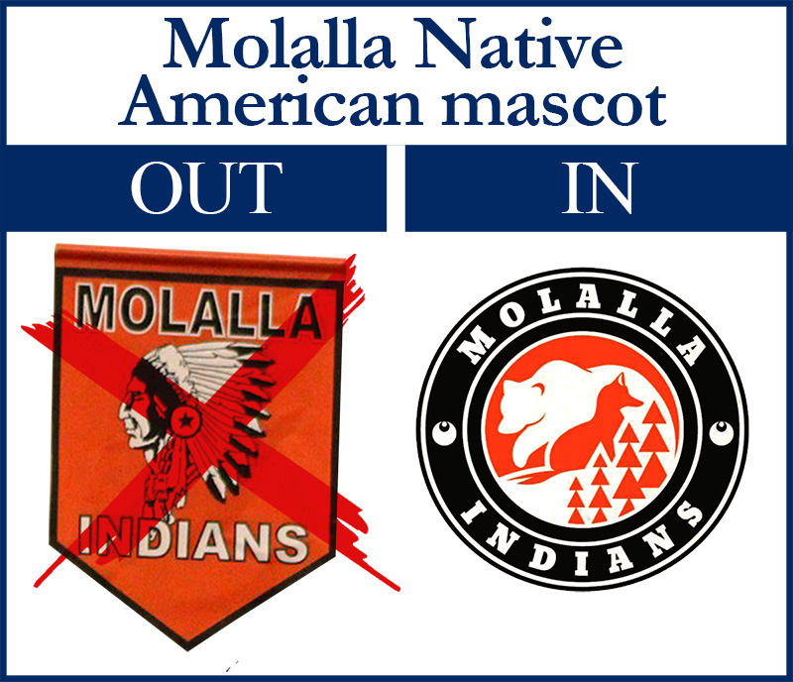

2008
Oregon Mascot Tensions

Oregon School Activities Association lists 16 Oregon high schools with mascots that many Indians feel ridicule their heritage. Aloha High School: Warriors, Amity High School: Warriors, Banks High School: Braves, Chemawa Indian School: Braves, Lebanon High School: Warriors, Mohawk High School: Indians, Molalla High School: Indians, North Douglas HS: Warriors, Philomath High School: Warriors, Reedsport High School: Braves, Rogue River HS: Chieftains, Roseburg High School: Indians, Scapoose High School: Indians, Siletz Valley School: Warriors, The Dalles Wahtonka HS: Eagle Indians, Warrenton High School: Warriors. OSAA has no regulatory authority. Change lies within the hands of the schools and Oregon Department of Education.

