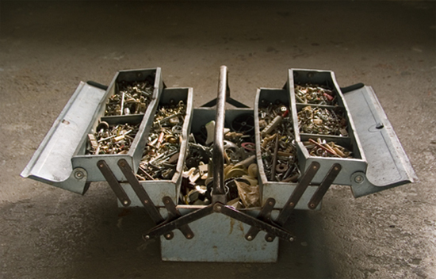

“It's funny: I always imagined when I was a kid that adults had some kind of inner toolbox full of shiny tools: the saw of discernment, the hammer of wisdom, the sandpaper of patience. But then when I grew up I found that life handed you these rusty bent old tools - friendships, prayer, conscience, honesty - and said 'do the best you can with these, they will have to do'. And mostly, against all odds, they do.”
― Anne Lamott, Traveling Mercies

